**Demo #1**

**Team:** Codework Digital

**URL:** **thetalkmadesimple.com**

**Team Members:** Cat Schnelle, Chanse Stephens, Kevin Sims, Elijah Pemberton

**Group #:** 4

**Course:** CSCI-441-VA-Software Engineering

**Github:**[**https://github.com/CSchnelle/Codework-Digital**](https://github.com/CSchnelle/Codework-Digital)

**Individual Contributions Breakdown**

**Demo #1**

Chanse Stephens

* **Programming:**
* Code for landing-page.php
* Code for header.php
* **Lead Front-End Design:**
* Implemented theme in WordPress
* **Project Management:**
* Created initial theme files
* Video Presentation for Demo
* Manage Repository Files
* Manage WordPress account
* Helped others test file changes

Cat Schnelle

* **Programming:**
* Code for footer.php
* Create widgets in WordPress
* Terms & Conditions Page
* Landing page links
* **Project Management:**
* Brochure
* Presentation slides
* Set up /manage repository
* Roadmap / Plan of Work

Elijah Pemberton

* **Programming:**
* Backend code for page.php and single.php (about section)
* Backend code for search.php (search bar)

Kevin Sims

* **Programming:**
* Backend code for 404.php (error handling)
* Backend code for header.php (header menu)
* Google Analytics

Project Management

Now that the team has implemented the base shell on WordPress with basic functionality on the landing page. We have created a functional store, profile, and course pages for our site and the main UI, template and theme have been designed and implemented for the landing page.

Going forward approaching our next demo we will be working on backend development for additional site features. This includes completing the search bar, which Elijah Pemberton is working on. Kevin Sims will be implementing Google Analytics to the site. The team will collectively help with implementing the theme consistently throughout the additional pages. We will be presenting the Demo to our client to receive feedback and we will spend the next week making UI changes at the request of our client. We will begin to integrate site content in the next few weeks as each page becomes fully completed and tested, provided by the client. We will begin to create an instructional manual for our client as we upload site content so that they will be able to maintain the site to their needs going forward. This week we will also be completing our courses display page so that it mirrors our landing page carousel. Chanse Stephens will continue operating as the Lead Front End Designer for the team; ensuring that all theme and design elements have been implemented consistently and assigning the team with individual tasks. Cat Schnelle will be working on completing social media integration with the site as well as any group tasks assigned, and keeping track with managing the plan or work and project roadmap. Cat will also perform test cases and provide feedback for bug fixes for the project as well continue forward.

Roadmap

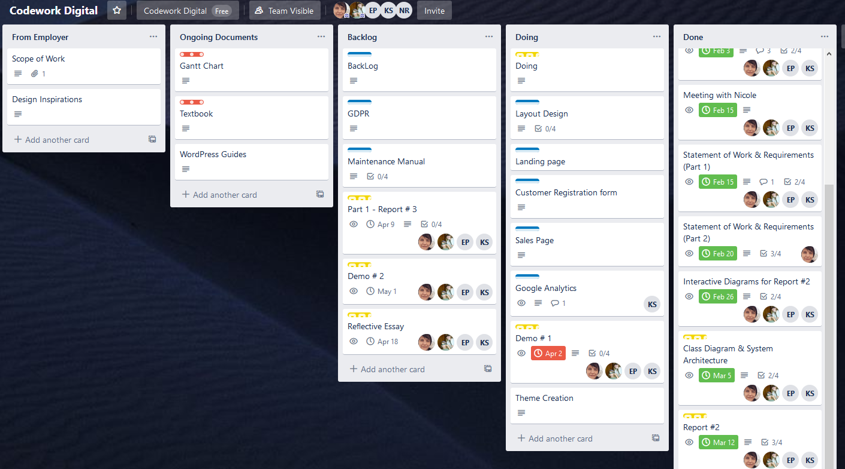

Plan of Work

